TEAM4OARS

Feasibility Study

Version 1.0

Signature Block

COSC 4351 | Name Signature | Date
SE Team Leader
SE SQA

REPLACE Team Project with your TEAM?OXXS all uppercase one word

Feasibility study content hints:

This document contains the information about the feasibility of the Team Project TEAM?OXXS that your team is going to OOA, OOD, and OO Implement.

Find existing similar software products:

- get link,
- get screenshots;
- get technology,
- get interface,
- get cost,

Each team member, including the TL should do this research.
Show good ones versus bad ones, and how they solved some of the technical issues, such as live chat, security.

In the process start PROTOTYPING (find the Artist and Psychologist in your Team) your Team Project TEAM?OXXS and decide on the WEB SITE design (MASTER PAGE wireframe), each web page design, colors, pictures, links, etc. There should be actual work on your Team Project TEAM?OXXS while investigating similar systems.

http://www.terraresidential.com/

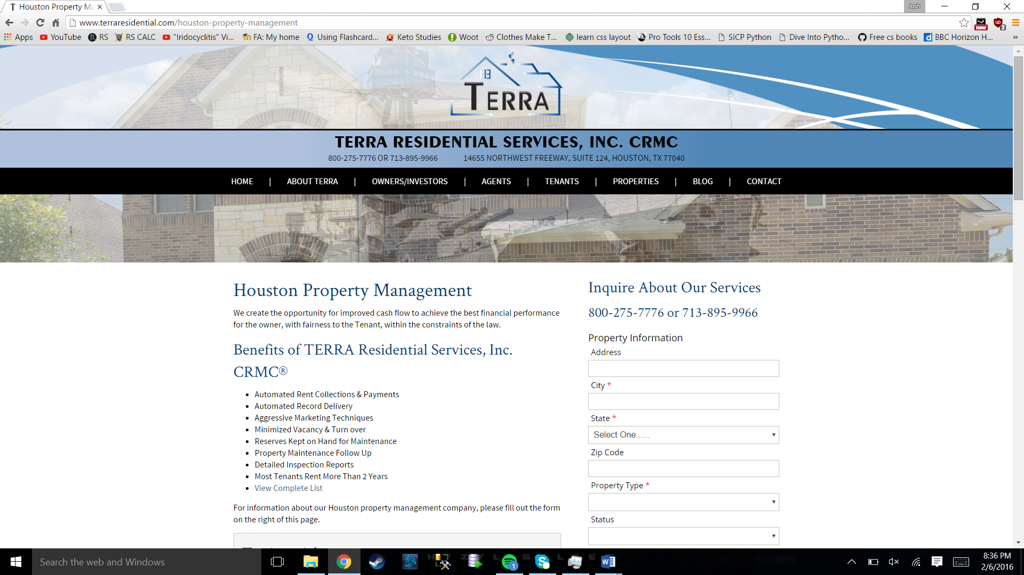
Bad Ideas:
- Cluttered and confusing.
- Current Listings doesn’t work as well as it should.
- Pricing not apparent.
Good Ideas:
- Number one on google.
- Website is simple to navigate through.
- Testomonials on homepage
- Application form looks really well.

http://houstonnrpm.com
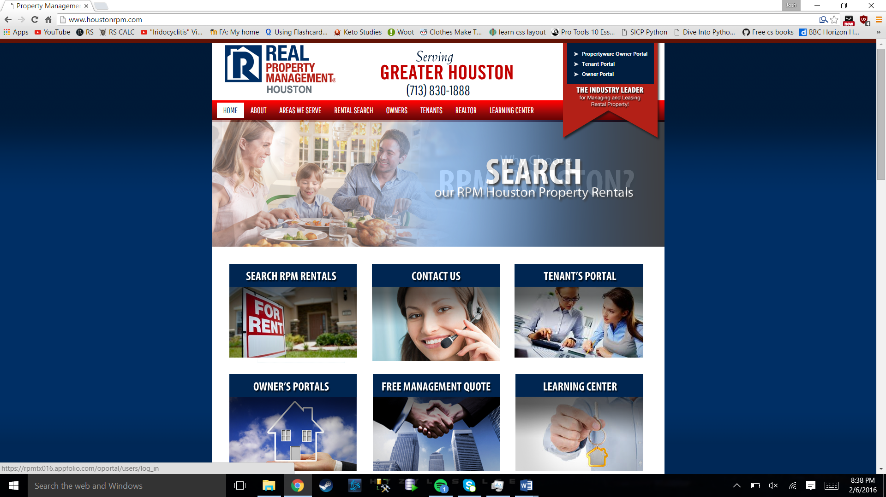
Bad Ideas:
- Horrible outdated design.
- Ads on homepage.
Good Ideas:
- Offers a good amount of plans right from the navigation bar.
- Open about their plans and offers.
- You can search through current users.

Change History

Table 1: TLs entries (assigned work and due dates) before releasing to the team
Revision | Name | Due Date | Description
1.1 | TM  Joshua Wilburn | 02/06/2016 | Research similar solutions to Project Requirements that are used in the Real World and send findings
1.1 | TM  Ali Khalid Elsaadi | 02/06/2016 | Research similar solutions to Project Requirements that are used in the Real World and send findings
1.1 | TM  Devin Bellomy | 02/06/2016 | Research similar solutions to Project Requirements that are used in the Real World and send findings
1.1 | DBA  Joseph Nguyen | 02/06/2016 | Research similar solutions to Project Requirements that are used in the Real World and send findings
1.1 | DBA  Stephen Carver | 02/06/2016 | Research similar solutions to Project Requirements that are used in the Real World and send findings
1.1 | SQA  Benjamin Wightman | 02/11/2016 | Research similar solutions to Project Requirements that are used in the Real World and send findings  Review Document after all findings have been submitted
1.1 | TL  Bertol Salgado | 02/06/2016 | Research similar solutions to Project Requirements that are used in the Real World and send findings. Go over and make a note

Table 2: Entries when work completed (SVN Commit Comment matches Description)
Revision | Name | Completed Date | Description
1.A | Ali Elsaadi TM | 2/6/2016 | I completed the feasibility study and I/O forms
1.B | TM & Name | XX/XX/XXXX | I …..
1.C | DBA & Name | XX/XX/XXXX | I …..
1.X | SQA & Name | XX/XX/XXXX | I reviewed Document

Table 3: TL entry for RED DELIVERABLES (SVN Commit Comment matches Description)
Revision | Name | Due Date | Description
2.0 | TL & Name | XX/XX/XXXX | I changed Version to 2.0

Document Storage
This file is stored in SVN at https://svn.cs.uh.edu/svn/cosc4351/team?/TEAM PROJECT DELIVERABLES/Feasibility Study.doc.

